

**2025-2026 Girls Club**

**Season Guide**



Fusion Volleyball is a community for volleyball players, coaches, and families. Our volleyball club program is a learning institution that teaches competitive volleyball through skills, systems and tactics. Our program is curriculum based in which all of our coaches learn and use club based language and training systems to accomplish an efficient learning system.

# **2025-2026 Teams**

This year we are proud to provide two levels of teams with more opportunities to play at the power level. Please see below for guidelines for each team and the teams we are estimating to field this year.

|  | **Power** | **Regional** |
| --- | --- | --- |
| **12.1** |  | X |
| **12.2** |  | X |
| **13.1** | X | X |
| **13.2** |  | X |
| **13.3** |  | X |
| **14.1** |  | X |
| **14.2** |  | X |
| **14.3** |  | X |
| **15.1** | X |  |
| **15.2** | X |  |
| **15.3** |  | X |
| **15.4** |  | X |
| **16.1** | X |  |
| **16.2** | X |  |
| **16.3** |  | X |
| **17.1** |  | X |
| **18.1** |  | X |

# **Power Teams**

Power Teams are the most competitive learning environments in the club. These teams are focused on training for the most competitive team outcomes and give the players the best opportunity to compete against some of the best competition around the nation.

**Cost**

Tuition - $4200

Tournament / Travel - est. $1982.50

**Time Commitments**

* Season runs from Mid November to end of May*
* 2-3 practices a week, depending on gym availability and tournaments
* 26 tournament days
  + 2-3 major travel
* Air travel will be necessary

*If a National Championship Bid is earned:

* Season is extended through end of June
* Additional cost will be calculated and invoiced

**Tentative Tournament Schedule**

| **Organization** | **Tournament/League** | **Location** | **Start Date** | **End Date** | **Days** | **Family Cost** |
| --- | --- | --- | --- | --- | --- | --- |
| WCVBA | Jamboree | Bay Area Sites | 12/6/2025 | 12/7/2025 | 2 | $ 74.17 |
| WCVBA | League Tournaments | Sacramento/ Bay Area Sites | 1/3/2026 | 5/2/2026 | 7 | $ 320.83 |
| WCVBA | Winter Classic | Bay Area Sites | 1/17/2026 | 1/19/2026 | 3 | $ 107.50 |
| AAU | Festival Fiesta | Phoenix, AZ | 2/14/2026 | 2/16/2026 | 3 | $ 290.00 |
| WCVBA | Spring Challenge | Roseville, CA | 3/7/2026 | 3/8/2026 | 2 | $ 163.33 |
| USAV | Windy City Qualifier | Chicago, IL | 4/3/2026 | 4/6/2026 | 3 | $ 462.50 |
| USAV | Far Westerns | Reno, NV | 4/11/2026 | 4/26/2026 | 3 | $ 266.67 |
| JVA | West Coast Cup | Long Beach, CA | 5/23/2026 | 5/25/2026 | 3 | $ 297.50 |
|  |  |  |  | Total Days | 26 | $ 1,982.50 |

# **Regional Teams**

Designed for those who may not be ready to compete at the power level, but are working to prepare for the highest level possible.

**Cost**

Tuition - $3300

Tournament / Travel - est. $755.83

**Time Commitments**

* Season runs from November to Mid May
* 20 total tournament days
  + 1 Travel Tournament (Roseville, Ca)
  + 1 National Qualifier (Reno, NV)
* All League Tournaments located in the Bay Area
* Practice 1-2 times a week, depending on gym availability and tournament schedule

**Tentative Tournament Schedule**

| **Organization** | **Tournament/League** | **Location** | **Start Date** | **End Date** | **Days** | **Family Cost** |
| --- | --- | --- | --- | --- | --- | --- |
| WCVBA | Jamboree | Bay Area Sites | 12/6/2025 | 12/7/2025 | 2 | $ 74.17 |
| WCVBA | League Tournaments | Bay Area Sites | 1/3/2026 | 5/2/2026 | 7 | $ 191.67 |
| WCVBA | Winter Classic | Bay Area Sites | 1/17/2026 | 1/19/2026 | 3 | $ 107.50 |
| AAU | Presidents Day Showdown | Bay Area Sites | 2/14/2026 | 2/16/2026 | 3 | $ 107.50 |
| WCVBA | Spring Challenge | The Grounds | 3/7/2026 | 3/8/2026 | 2 | $ 163.33 |
| USAV | Far Westerns | Reno, NV | 4/11/2026 | 4/26/2026 | 3 | $ 111.67 |
|  |  |  |  | Total Days | 20 | $ 755.83 |

# **2025-2026 Tryouts**

Our tryout process is a systematic experience designed to assess your athlete in her specific role based on the skills we believe necessary to assign her to a team that best fits her play style and abilities. Throughout the tryout, each player will have their opportunities to be evaluated by multiple coaches, multiple times.

**Step 1: Register for Tryouts**

* Tryout registration link can be found on our website ([fusionvball.com](http://fusionvball.com))
* Tryout Clinics and Tryouts will be held at Independence High School and Pioneer High School.

**Step 2: Attend Tryout Clinics**

The Tryout Clinics are designed for players to get contacts prior to tryouts and meet our Fusion staff. During the Tryout Clinics, coaches may make soft offers.

**High School Tryout Clinic Dates & Times**

15U

| Day | Date | Time | Location |
| --- | --- | --- | --- |
| Wednesday | 7/16/2025 | 7:00pm - 9:00pm | Independence High School |
| Saturday | 7/19/2025 | 10:00am - 12:00pm | Independence High School |
| Wednesday | 7/23/2025 | 5:00pm - 7:00pm | Pioneer High School |

16U, 17U, & 18U

| Day | Date | Time | Location |
| --- | --- | --- | --- |
| Wednesday | 7/16/2025 | 7:00pm - 9:00pm | Independence High School |
| Saturday | 7/19/2025 | 10:00am - 12:00pm | Independence High School |
| Wednesday | 7/23/2025 | 7:00pm - 9:00pm | Pioneer High School |

**Youth Tryout Clinic Dates & Times**

14U & Below

| Day | Date | Time | Location |
| --- | --- | --- | --- |
| Saturday | 9/27/2025 | 7:00pm - 9:00pm | TBD |
| Saturday | 10/4/2025 | 10:00am - 12:00pm | TBD |
| Wednesday | 10/8/2025 | 7:00pm - 9:00pm | TBD |

12/13U & Below

| Day | Date | Time | Location |
| --- | --- | --- | --- |
| Saturday | 9/27/2025 | 7:00pm - 9:00pm | TBD |
| Saturday | 10/4/2025 | 10:00am - 12:00pm | TBD |
| Wednesday | 10/8/2025 | 7:00pm - 9:00pm | TBD |

**Step 3: Attend Tryouts**

Players will be evaluated on their skills based on the positions they are trying out for. Teams will be finalized. Make up tryouts will be held if needed.

**Tryout Dates & Times**

15U

* Saturday, July 26 @ 9:00 AM - 11:30 AM

16U, 17U, & 18U

* Saturday, July 26 @ 12:30 PM - 3:00 PM

14U & Below

* Saturday, October 8th @ TBD

12U/13U & Below

* Saturday, October 8th @ TBD

**Step 4: Team Offers / Waitlist**

Team Offers

* A formal offer will be sent through the email registered to PlayMetrics.
* Players will have 24 hours to make a decision after emails are sent.
* Head Coaches will call families to confirm the offer was received and answer any questions.
* Families must accept through the PlayMetrics platform to officially accept the offer.

Waitlist

* An email will be sent through PlayMetrics to those who have been added to the waitlist
* You can inquire about your location on the waitlist if you wish
* Coaches will make offers to those on the waitlist after the 24 hour waiting period

# **Cost and Billing**

The cost of the season is divided into three components: Tuition, Tournament/Travel Fees, and Gear. Each is outlined below.

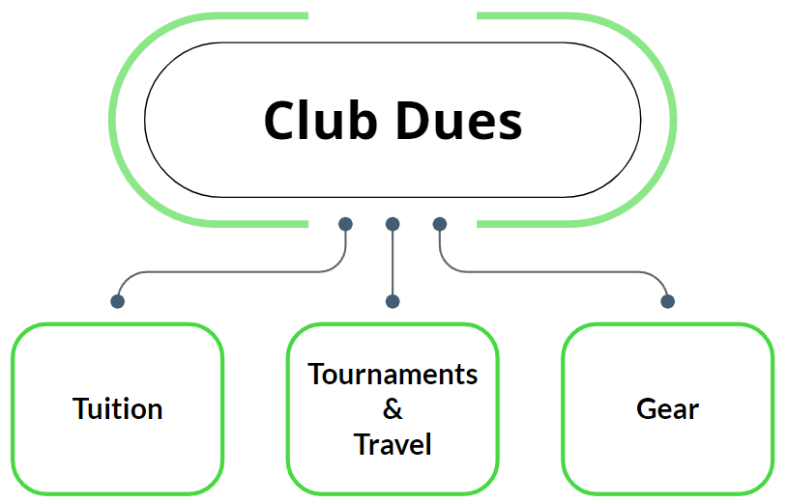

**2025-2026 Season Tuition**

Season tuition includes the general fixed cost of the club season. Coaching Salaries, Gym Rentals, Governing Body Team Registrations fees, General Club Operations, Equipment.

Power - $4200

Regional - $3300

Billing

* Can be paid in full at signing (July 30, 2025 (HS), October (Youth))
* Billed in three even installments
  + Signing Day (July 30, 2024 (HS), October (Youth))
  + January 1, 2025
  + February 1, 2025

**Tournament/Travel Fees**

The cost of the tournaments and the travel for coaches are separated to allow for more accuracy and transparency. Included in the Tournament/Travel Fees are tournament entry fees, all coaches travel including airfare, hotel, ground transportation, and coaches per diem for all travel tournaments.

Families are responsible for the travel and lodging arrangements for themselves and their athletes. We believe this creates a safer and more appropriate environment for our families and athletes. There will be certain tournaments where there is a requirement to stay at certain hotels and room blocks. These are called “Stay to Play” and we will notify teams ahead of time regarding which tournaments these are and the timing of books. Fusion Volleyball has acquired room blocks for our families to use this season. We believe this aids in a better team dynamic and ease of planning.

**Tournament Estimates**

Below are estimates covering the following tournaments per family with a team of 12. This will vary depending on the size of the team and location assigned to the team. Power Teams will travel more, Regional Teams will travel as needed.

## **Tournament Estimates**

Below are estimates covering the following tournaments. This will vary depending on the size of the team.

| **Tournament** | **Individual Family** |
| --- | --- |
| Jamboree | $ 74.17 |
| WCVBA Power League | $ 320.83 |
| WCVBA Regional League | $191.67 |
| WCVBA Winter Classic | $ 107.50 |
| Presidents Day Showdown | $107.50 |
| Fiesta Presidents Day | $ 290.00 |
| Spring Challenge | $ 163.33 |
| Windy City Qualifier | $ 462.50 |
| Far Westerns | $ 266.67 |
| West Coast Cup | $ 297.50 |

*This is an estimate based on a 12 team roster and tournaments can be added. **These are not additional charges, they are included in the listed tournament/travel fee.**

**Gear Breakdown**

Fusion is focused on finding benefits for families wherever possible. One of those ways is to allow for gear to be used during a 2 year cycle instead of purchasing new gear each year. Below is the gear for this year that is the 2nd year cycle of our two year cycle and general cost for each level. New players will be required to purchase the entire package. Returning players will have the option to purchase any items they would like replaced and new seasonal items as well.

| **Regional Package** | |
| --- | --- |
| Sleeveless Jersey 1 | $ 65.00 |
| L/S Jersey | $ 65.00 |
| Arm Sleeves 1 Set | $ 35.00 |
| S/S Practice Shirt 1 | $ 25.00 |
| S/S Practice Shirt 2 | $ 25.00 |
| Leggings 1 | $ 40.00 |
| Sweat Pants | $ 40.00 |
| Hoodie | $ 65.00 |
| Ball | $ 55.00 |
| Backpack | $ 60.00 |
| Bag Tag | $ 5.00 |
| **Est. Total** | $ 475.00 |

| **Power Package** | |
| --- | --- |
| Sleeveless Jersey 1 | $ 65.00 |
| Sleeveless Jersey 2 | $ 65.00 |
| Long Sleeve Jersey 1 | $ 65.00 |
| Arm Sleeves 2 sets | $ 70.00 |
| S/S Practice Shirt 1 | $ 25.00 |
| S/S Practice Shirt 2 | $ 25.00 |
| S/S Practice Shirt 3 | $ 25.00 |
| Leggings 1 | $ 65.00 |
| Leggings 2 | $ 65.00 |
| Hoodie | $ 65.00 |
| Ball | $ 55.00 |
| Backpack | $ 60.00 |
| Sweat Pants | $ 40.00 |
| Bag Tag | $ 5.00 |
| **Est. Total** | $ 695.00 |

# 

# **2025 - 2026 Practice Sites and Guidelines**

The exact practice schedule will be finalized by Early October. This is due to the site's ability to coordinate their activities with our practice.

1. [Edenvale Community Center](https://www.sanjoseca.gov/Home/Components/FacilityDirectory/FacilityDirectory/32/2040)
2. [Pioneer High School](https://pioneer.sjusd.org/)
3. [Bernal Intermediate School](https://bernal.ogsd.net/)
4. [Martin Murphy Middle School](https://martinmurphy.mhusd.org/)
5. [Dolores Huerta Middle School](https://huerta.santaclarausd.org/)
6. [Kathleen Macdonald High School](https://macdonald.santaclarausd.org/)
7. [Leland High School](https://leland.sjusd.org/)
8. [Evergreen Valley College](https://www.evc.edu/)

